Atria Institute of Technology



**Department of Information Science and Engineering**

**Big Data Analytics (18CS72)**

**Assignment-1**

**SUBMITTED BY**

Name: SANIKA

USN:1AT20IS082

Section: ISE-B

Submission Date: 27-11-2023

**Course Handling Faculty Name:**

Dr. K S Ananda Kumar

Associate Professor

Dept of ISE, Atria IT.

**Table of contents**

|  |  |
| --- | --- |
| **Sl. No** | **Description** |
| 1 | Instance creation in AWS Cloud  INSTANCE NAME - Sanika  INSTANCE TYPE - t2.micro/any other also.  key pair name- Sanika  storage - 10 GB  Screenshots  Private IP address and Public IP address. |
| 2 | Installing PUTTY  Execution of basic Linux commands on the instance |
| 3 | GitHub Repository link |

**INSTANCE CREATION**

* Launch an EC2 Instance in AWS , give a name and tag of your choice.

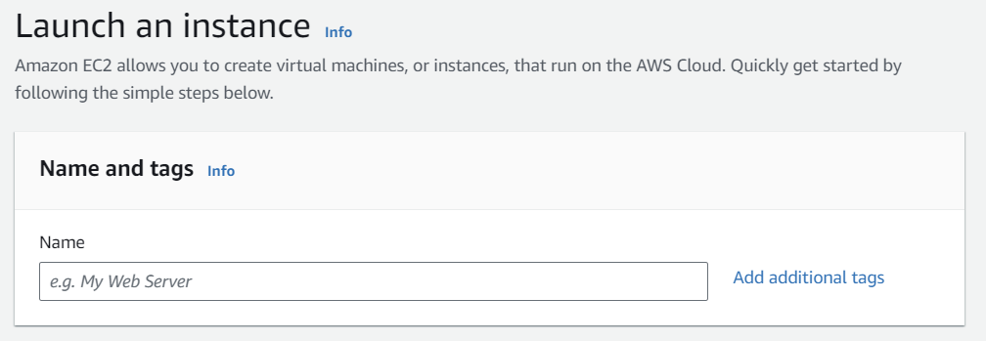

* 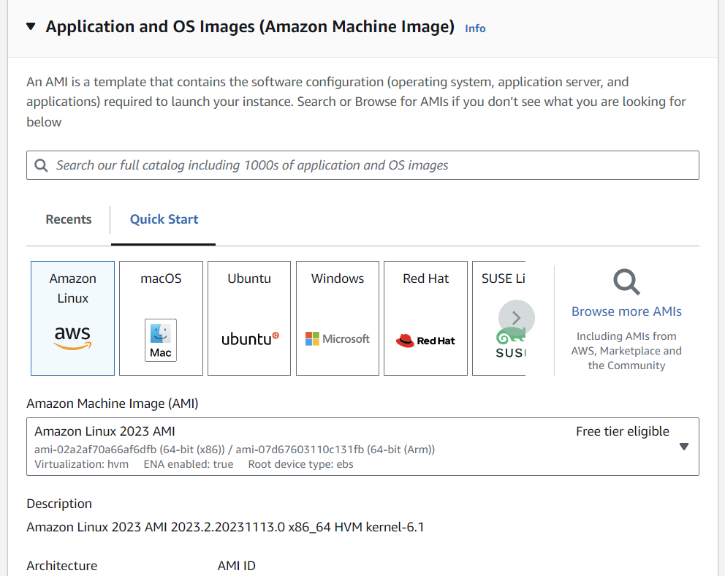Select an Operating System of your choice to create an AMI (Amazon Machine Image)
* 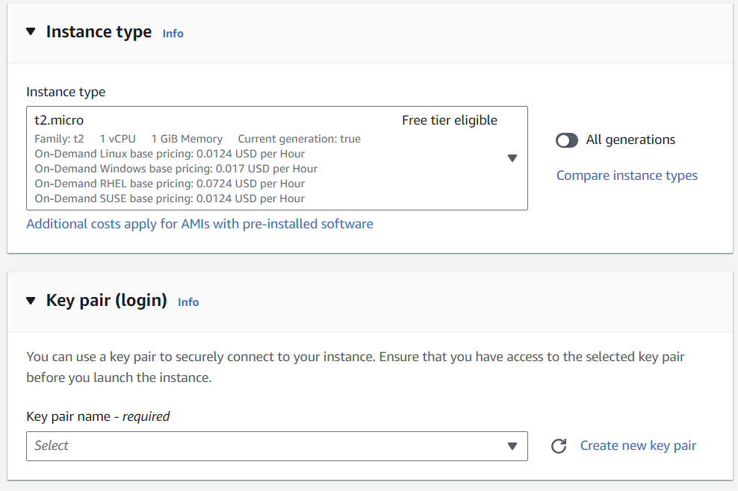Choose an Instance type and give a key pair name. You can use a key pair to securely connect to your instance. Ensure that you have access to the selected key pair before you launch the instance.
* 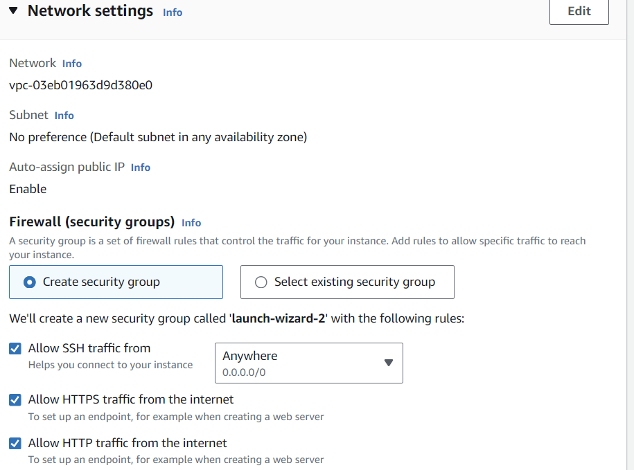Create a security group and select protocols that are needed.
* 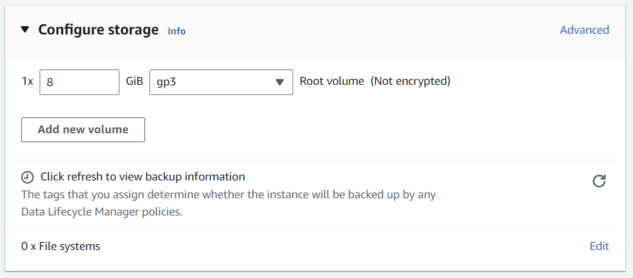Configure storage.
* 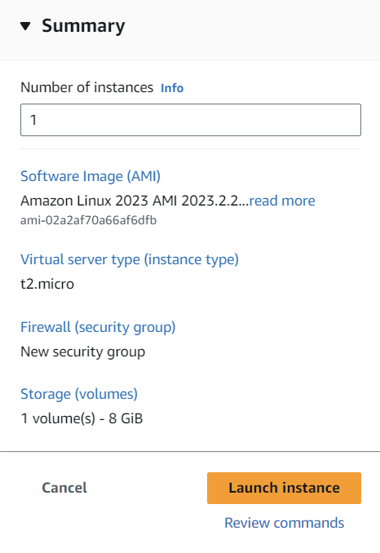Check the summary to confirm the type of Instance you want to launch and launch the instance.

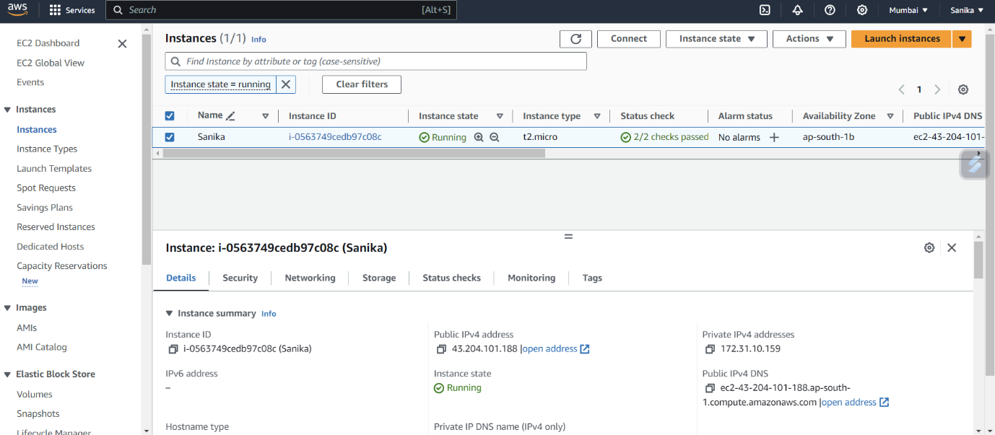**SCREENSHOTS OF AWS INSTANCE**

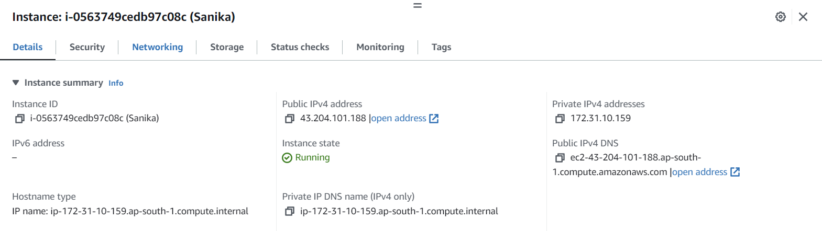

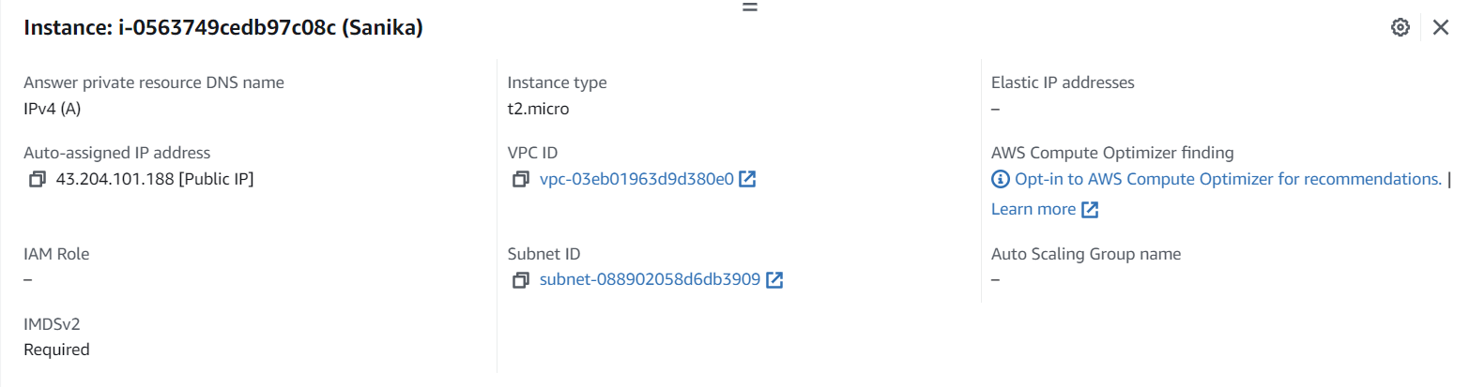

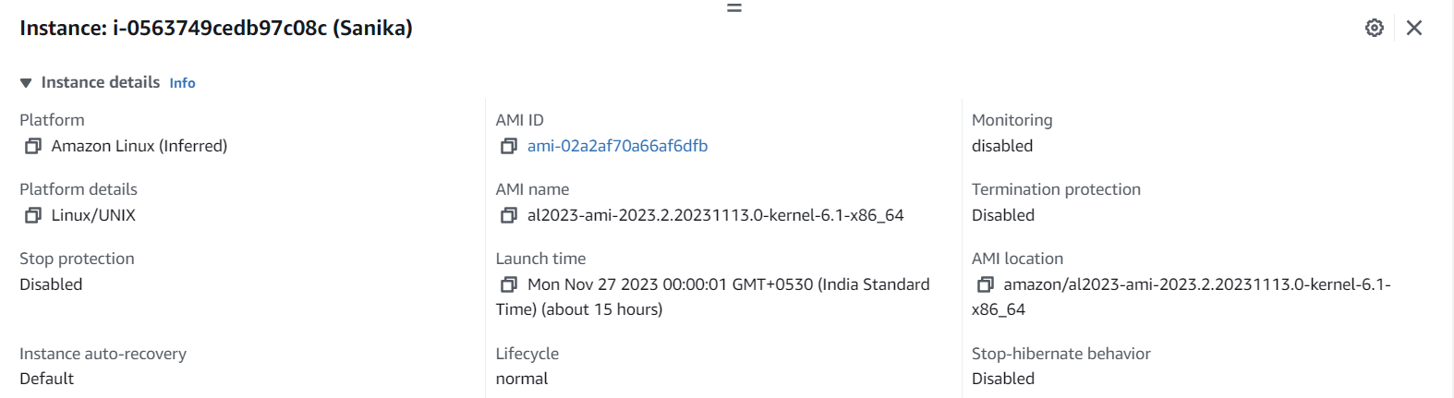

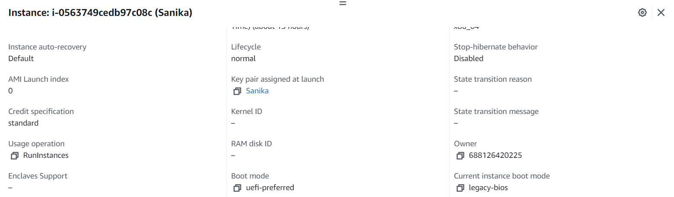

* Instance:

i-0563749cedb97c08c (Sanika(Linux server))

* Instance ID:

i-0563749cedb97c08c (Sanika(Linux server))

* Public IPv4 address:

43.204.101.188

* Private IPv4 addresses:

172.31.10.159

* Instance state:

Running

**RUNNING SAMPLE PROGRAM ON LINUX INSTANCE**

* Install PUTTY for debugging and connecting to serial ports and to raw sockets.
* 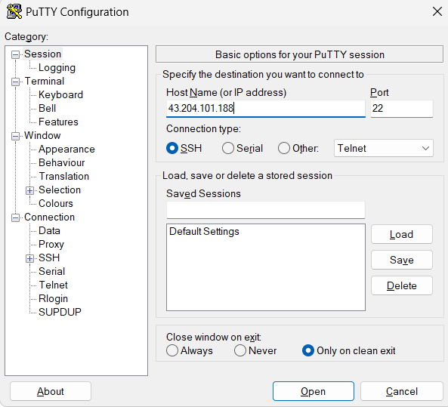In putty under host name enter the Public IPv4 address.
* 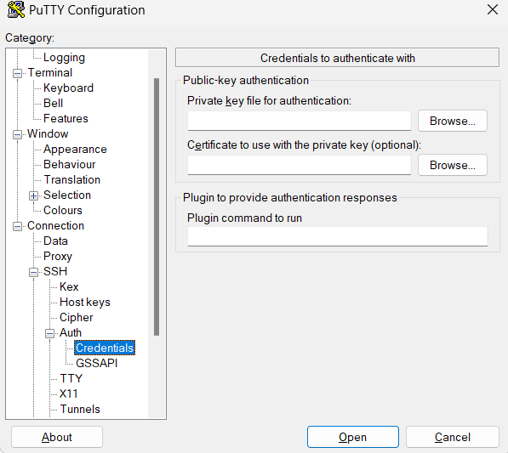Under Auth in private key file for authentication browse and add the PuTTY Private Key File (.ppk) named Sanika-linux.
* 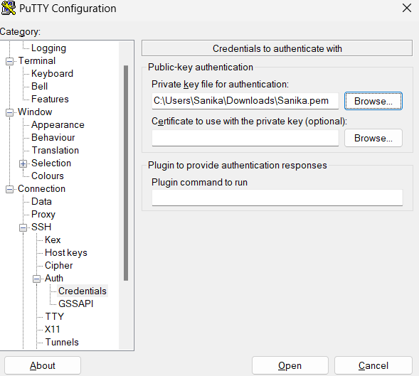After browsing click on Open button
* 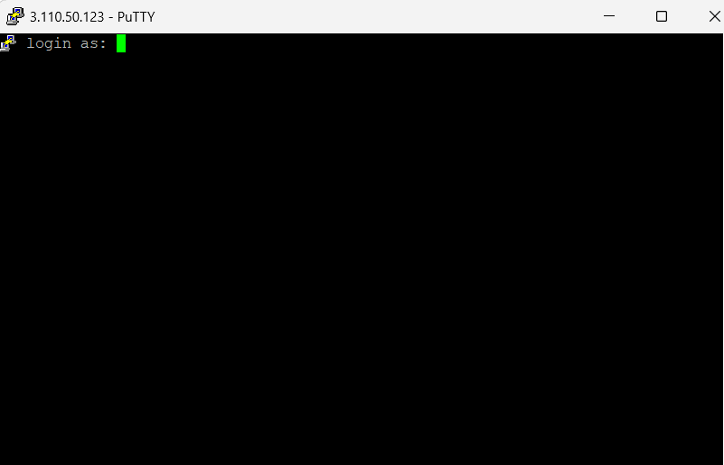This directs us to this screen now enter the User name that is ec2-user.
* 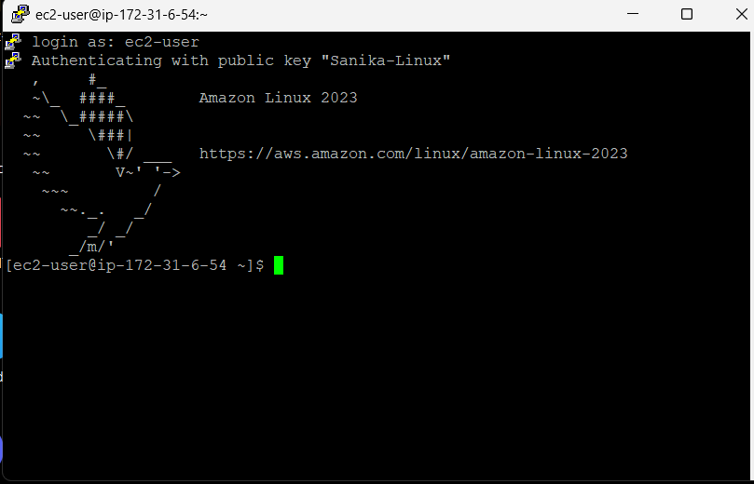After successful login it authenticates and now we can enter any commands.

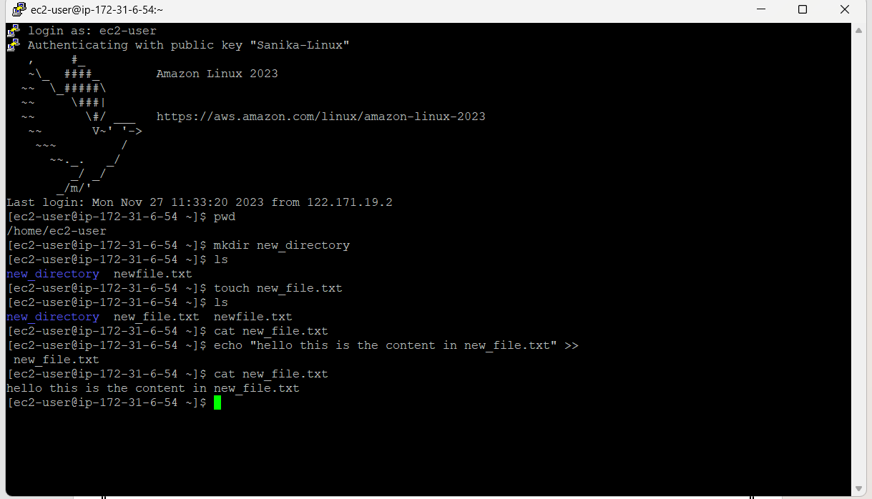**LINUX COMMANDS USED IN PUTTY**

* pwd:

pwd is used to present working directory, this gave the output /home/ec2-user.

* mkdir:

The mkdir (**m**a**k**e **dir**ectory) command creates a new directory in the provided location. I have created a directory called new_directory .

* ls:

The ls command (**l**i**s**t) prints a list of the current directory's contents. Therefore we got the directory created display as output.

* touch:
* The touch command's primary purpose is to modify an existing file's timestamp. The command creates an empty file if it does not exist. Due to this effect, touch is also a quick way to make a new file (or a batch of files).
* Here I have created a txt file called new_file first then a second txt file called file_txt.
* Using ls command we can find where these files have been created .
* cat:
* The cat command (con**cat**enate) displays the contents of a file in the terminal (standard output or stdout).
* To use the command, provide a file name from the current directory.
* Here I provide the txt file called new_file.txt.
* echo:
* The echo command to print arguments to the terminal.
* Here I have used echo “hello this is the content in new_file.txt”.
* The >> operator redirects output to a file.
* Later I use cat to find the content in new_file.txt. Therefore we can see that “hello this is the content in new_file.txt” has been added to new_file.txt cat file.txt is executed to show that there is no content in file.txt.